# **DevOps Pipeline for a Machine Learning Project**

The terms ‘MLOps’ and ‘AIOps’ are appearing more and more. Many from a traditional DevOps background might wonder why this isn’t just called ‘DevOps’. In this article we’ll explain why MLOps is so different from mainstream DevOps and see why it poses new challenges for the industry.

## Machine learning is getting more and more popular in applications and software products, from accounting to face recognition apps. When you add machine learning techniques to exciting projects, you need to be ready for a number of difficulties. The[Statsbot](http://statsbot.co/?utm_source=blog&utm_medium=article&utm_campaign=devops_ml) team asked Boris Tvaroska to tell us how to prepare a DevOps pipeline for an ML based project.**Current State of DevOps vs MLOps**

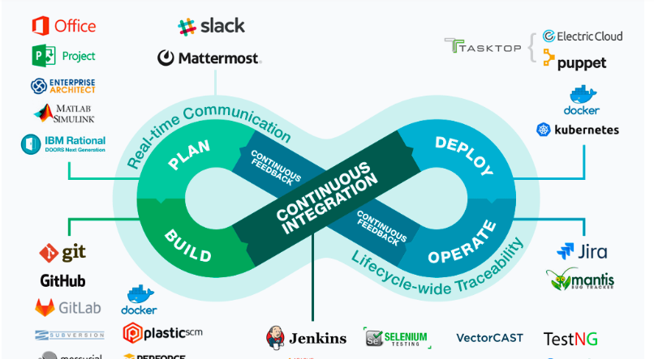

DevOps is now a relatively well-established set of practices based around CI/CD and infrastructure. DevOps practitioners put tools and processes in place to realise faster time to value and greater governance for software development projects. The space of [tools](https://medium.com/edureka/devops-tutorial-89363dac9d3f?ref=hackernoon.com) includes git, Jenkins, Jira, docker, kubernetes etc.:

MLOps has not achieved the same level of maturity. As much as [87%](https://venturebeat.com/2019/07/19/why-do-87-of-data-science-projects-never-make-it-into-production/?ref=hackernoon.com) of machine learning projects never go live. ML infrastructure is complex and workflows extend beyond production of artifacts to include data collection, prep and validation. The types of hardware resources involved can be specialised (e.g. GPUs) and require management. The data flowing through the model and the quality of predictions can also require monitoring, resulting in a [complex MLOps landscape](https://papers.nips.cc/paper/5656-hidden-technical-debt-in-machine-learning-systems?ref=hackernoon.com):

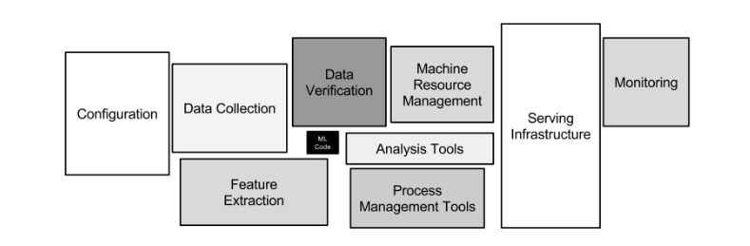

In this program i have four job

Job1 :  download the code from github if any change occure

Job2: Run the deep learning program if the accuracy of  the

model is below the 95 then sent mail how much accuracy your

model have.

Job3:  add layer inside program when accuracy below 95%

Job4:  deploye this program

These jobs are automatical trigger don’t need to trigger it.

Follow this step to create program

CREATE DOCKER IMAGE FOR MACHINE LEARNING :

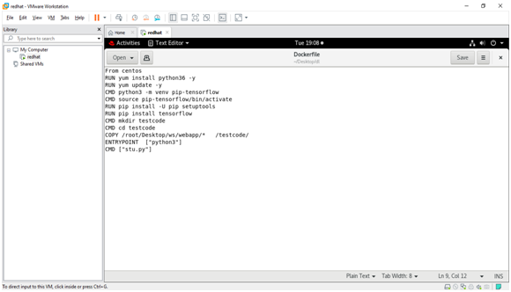

Dokcer has some key word to create dockerfiel to create images of dokcer

FROM (images name here)

COPY (name of directory from where you want to copy file or folder) (dir of centianer where you want copy)

WORKDIR (name which is your working dir)

RUN (run program )

CMD ( wrote cmd which you want to run )

*First configure your jenkins for sending mail configure file open:

gedit /etc/sysconfig/jenkins

then makes this changes their and restart jenkins

JENKINS_JAVA_OPTIONS="-Djava.awt.headless=true -Dmail.smtp.starttls.enable=true -Dmail.smtp.ssl.protocols=TLSv1.2

 JENKINS_ARGS="-Djava.net.preferIPv4Stack=true"

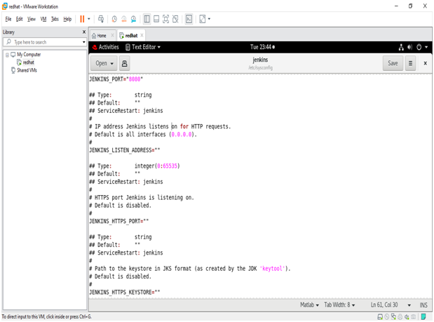

JOB1:

Job 1 download the code from github and copy inside docker persistent storage deep_story check inside docker document the provide all information how to create storage inside docker .

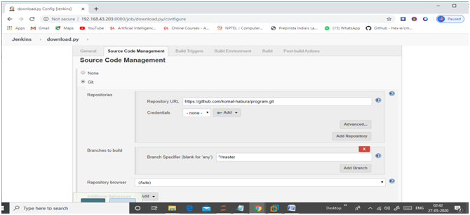

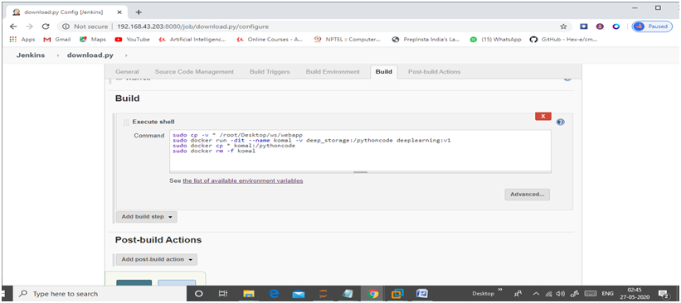

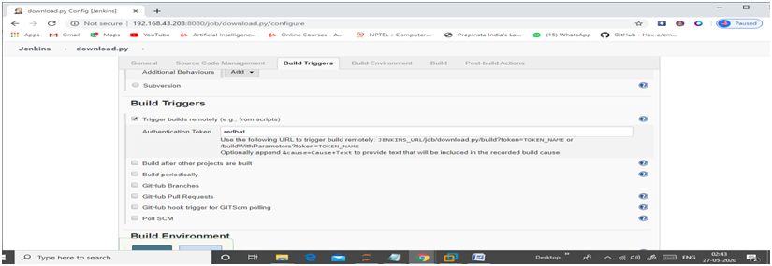

Job2 :

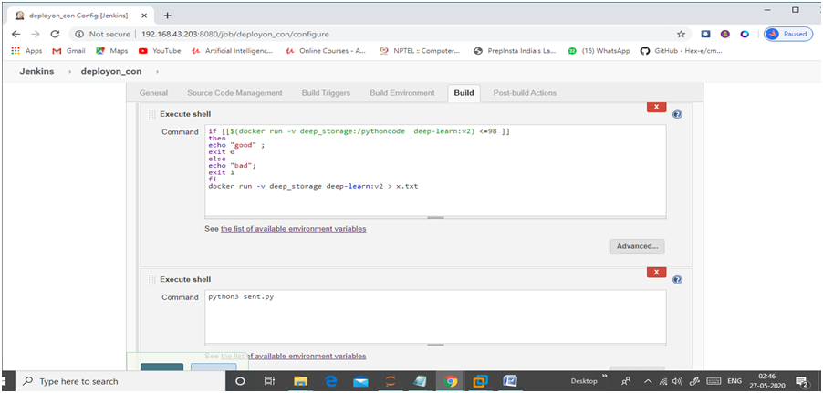

inside git hooks file make post-commit of git script .which trigger jenkins and automatically push file inside github when you commit the file.

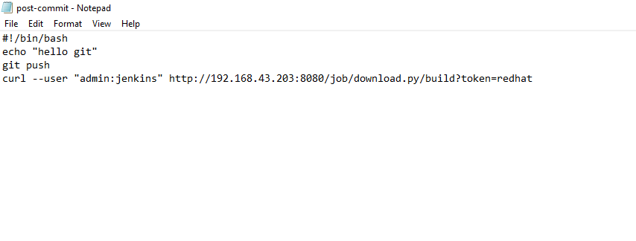

this hooks create inside git to trigger Jenkins remotely and upload file inside github when you commit.

Job3:

This job add some layer inside program when accuracy less than 87.

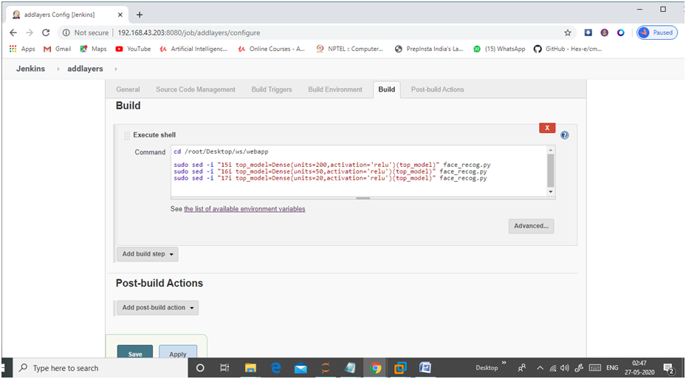

Job4:

This job post the modify program insde github

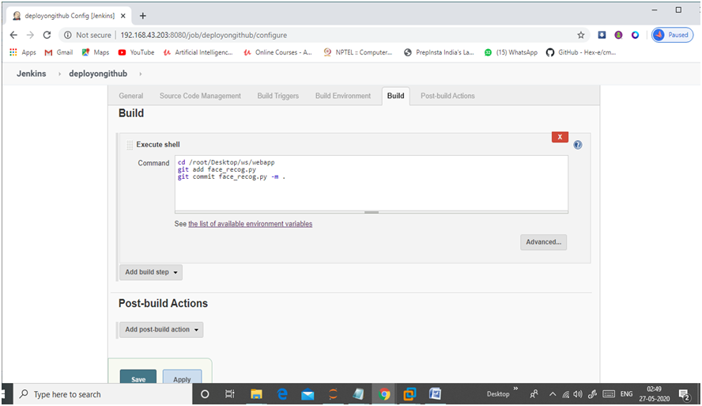

thanks to read my artical .